IKEA King Size Bed

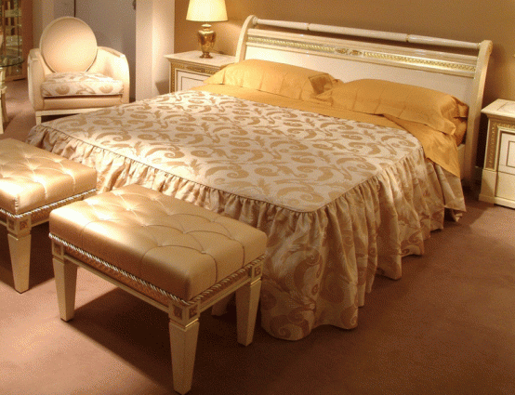

|  |
| --- |
| **DESCRIPTION** |
| IKEA introduces wooden bed which redefines the power of wood. This bed is guaranteed to create the perfect look in any house. The rich wood makes you feel very important it gives you royalty at affordable rates. The King Size Double Spring Mattress that the Kings bed has differs from normal ordinary bed. Perfect for a large room of the house, your guests will love this comfortable mood lifting bed. |

|  |  |  |
| --- | --- | --- |
| **Price** | **3455$** | |
| **Dimensions** | **H** x **W** x **L** | **35in x 70in x 85in** |
| **Features** | **King Size double spring bed makes it worth and makes it more soothing than ever before.** | |
| **Finished** | **Curtain Thread Crust** | |
| **Available in** | **Silver and Peach** | |